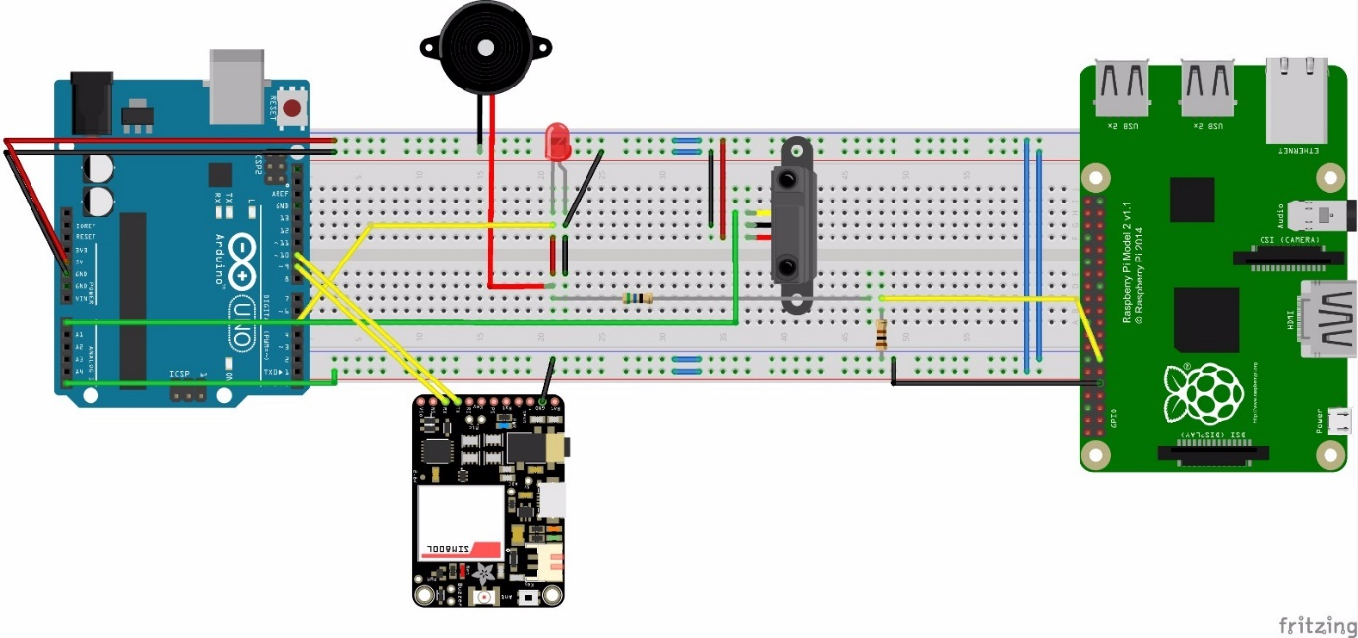**All the wires connected to:**

* Ground are black in color
* 5V are red in color
* Output from Arduino are Yellow in color
* Input for Arduino are green in color

**Input from sensors:**

* Output from the distance sensor built using IR LED and photodiode is connected to pin A0.
* Output from Wire cut (5V) is connected to A5.

**Output to different modules and components.**

Digital Pin number 5 goes high if the theft is detected. So it is connected to:

* An LED
* A piezo electric Buzzer
* Raspberry Pi pin number 13 (GPIO 27) through a 56Ohm resistor in series and a 100ohm resistor across the ground wire.

TX and RX pins of the GSM modules are connected to 9 and 10 digital pins of the Arduino which is configured using the SoftwareSerial module.

The GSM Module, Raspberry Pi, Distance sensor, LED and piezo electric buzzer are grounded using the Arduino.